19 L1 — Accumulation, Previous Belt Contact and Structural Deterioration
The L1 area shows several conditions that need to be considered together but not automatically attributed to one common cause. Material and fines have accumulated across the conveyor/access area and are also present on and around parts of the supporting structure. Local concrete deterioration includes material loss and exposed reinforcement, while separate steel support locations show substantial corrosion and section loss. Wear slots are also visible beside the belt path and are consistent with previous or intermittent belt-to-structure contact.
In the operating condition captured during the inspection, the belt was running clear of the affected supports and no obvious lateral offset, mistracking or contact was visible. The operating circumstances that produced the wear marks were not witnessed and therefore remain to be established. Follow-up should combine competent structural assessment of the deteriorated concrete and steel, measurement of the wear/contact geometry and representative tracking/clearance checks, together with measures to reduce recurring material, fines and moisture retention around any repaired structural interfaces. The photographs establish the visible condition but do not determine remaining structural capacity or prescribe the final repair arrangement.
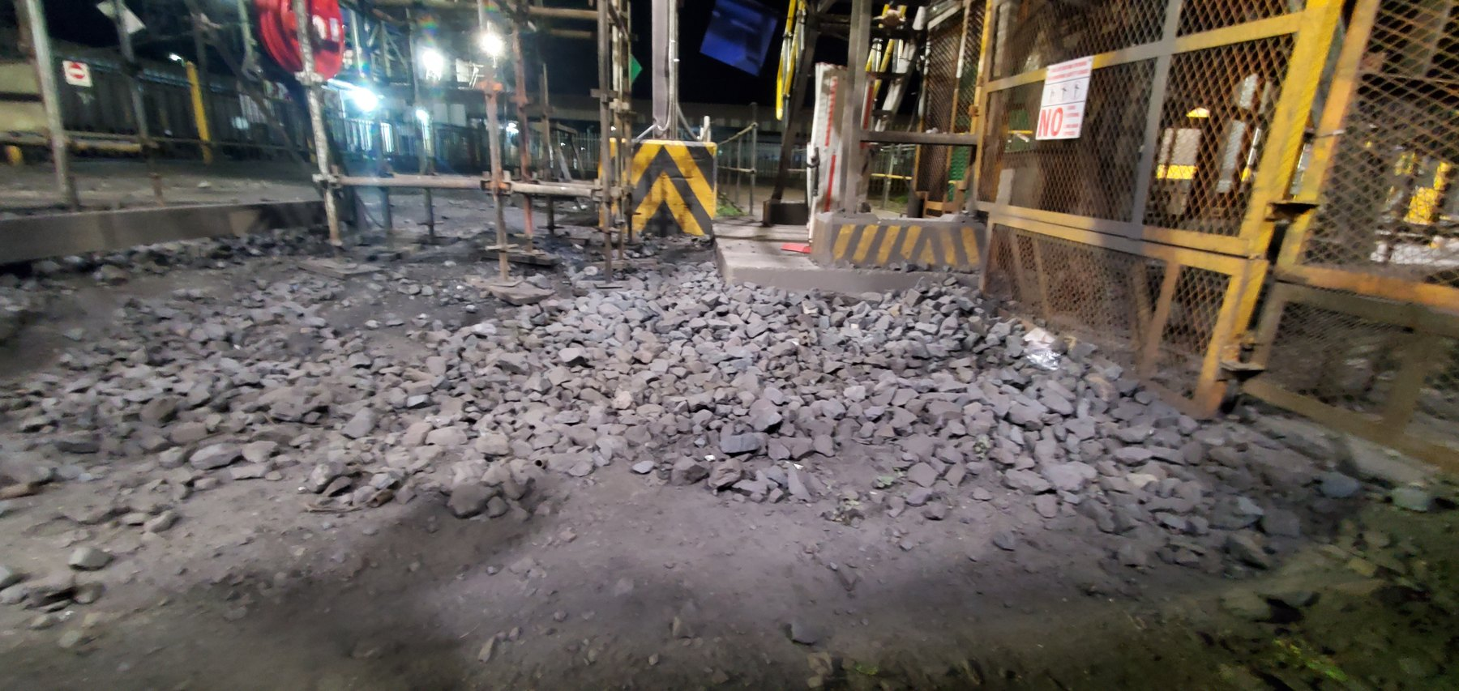  LoadoutStationL1-REF-013 — Broad view showing extensive material and fines accumulation across the L1 conveyor/access area. | 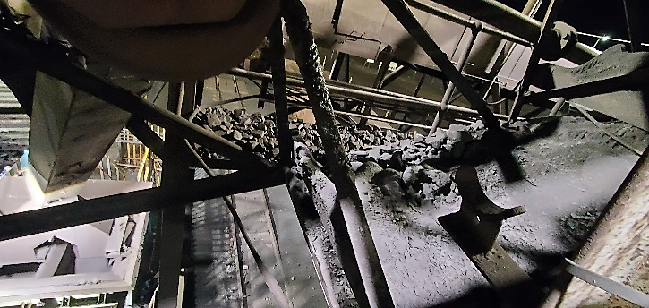  LoadoutStationL1-REF-017 — Elevated view showing material accumulation retained on and around the L1 structural members, complementing the broader floor/access-area accumulation shown in REF-013.

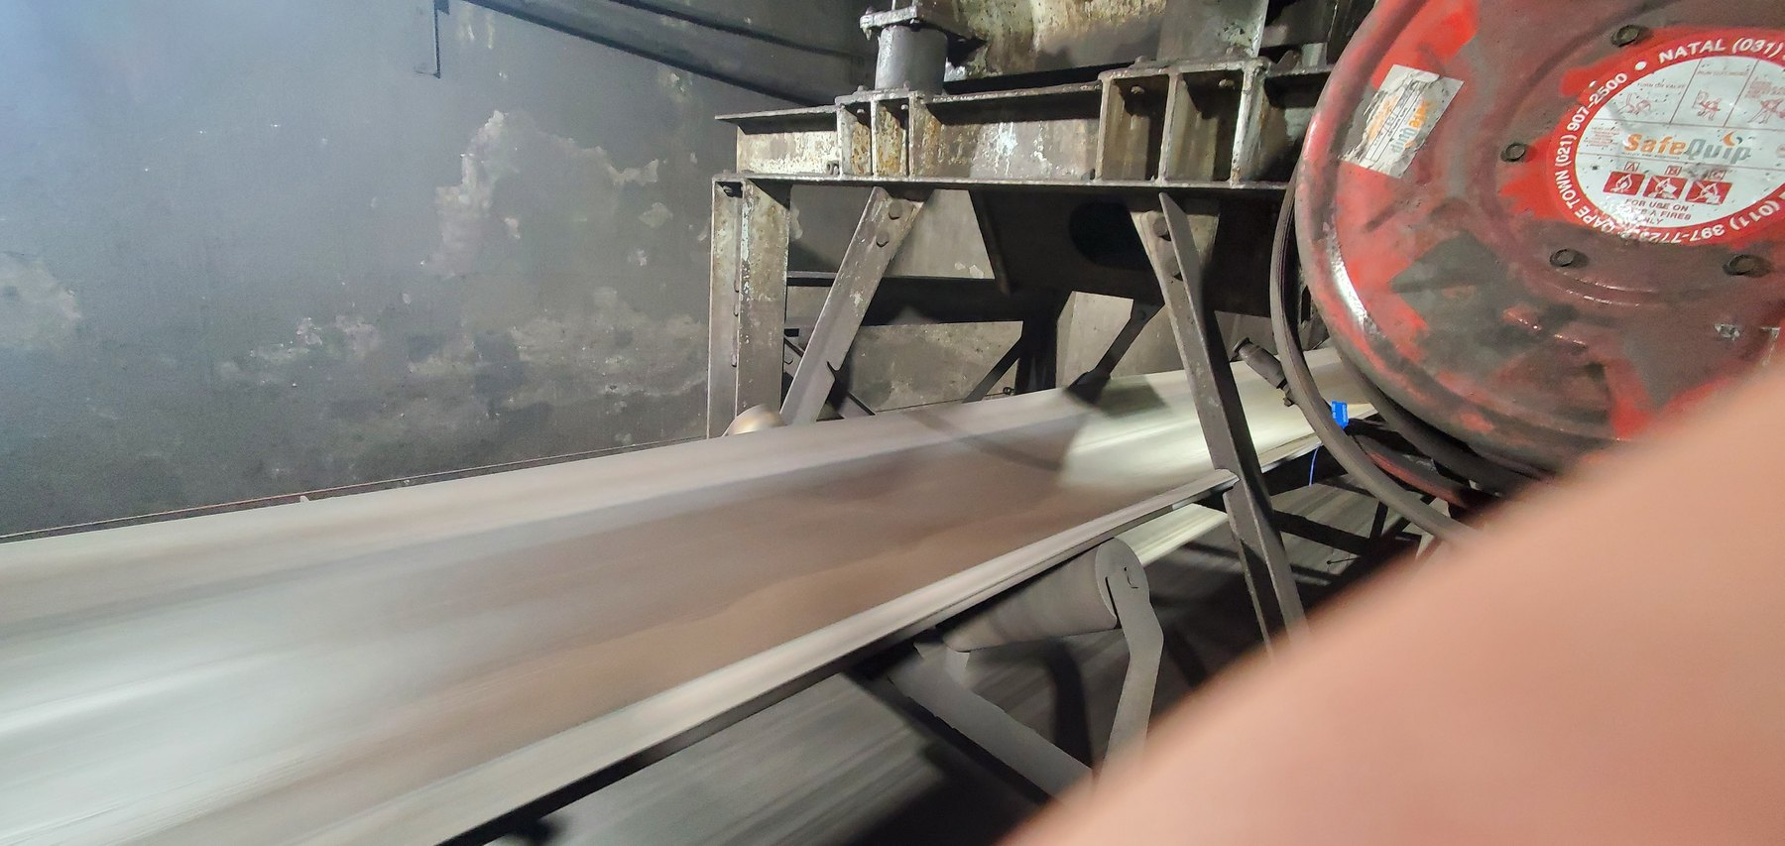
LoadoutStationL1-REF-007 — Wear slots adjacent to a belt that was running clear at the inspected condition. The wear is consistent with previous or intermittent belt-to-structure contact, while continuous present contact is not established.

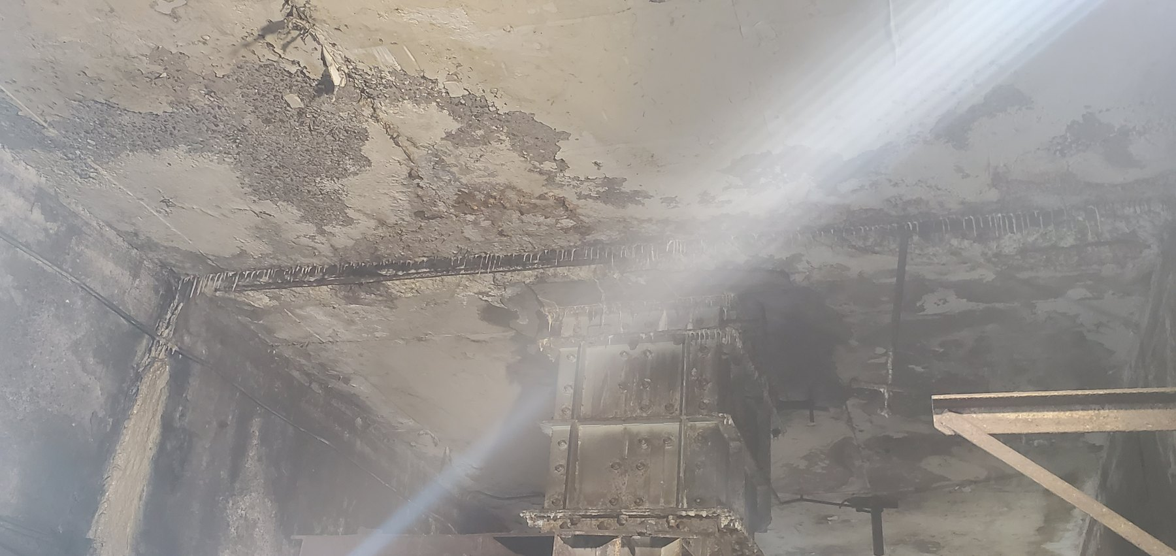
LoadoutStationL1-REF-004 — Wider view showing the location and surrounding context of concrete deterioration at L1.
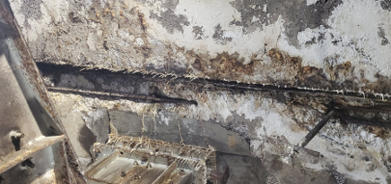
LoadoutStationL1-REF-005 — Close view showing substantial concrete material loss/spalling with exposed reinforcement. Remaining structural capacity cannot be determined from the photograph.

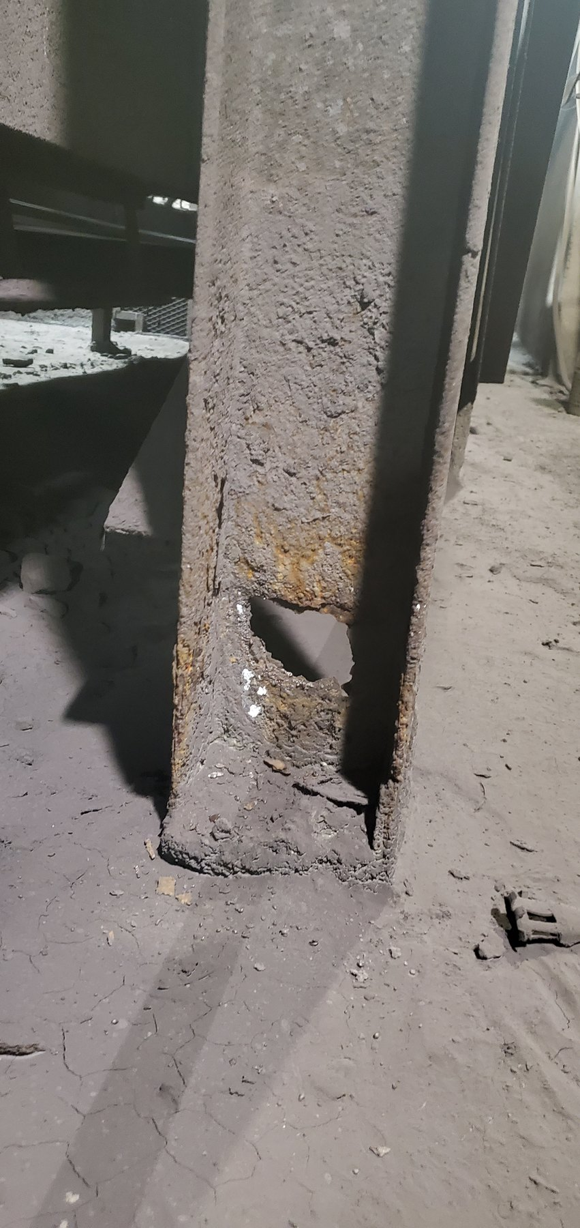  LoadoutStationL1-REF-008 — Local steel deterioration and section loss at one L1 conveyor support location. | 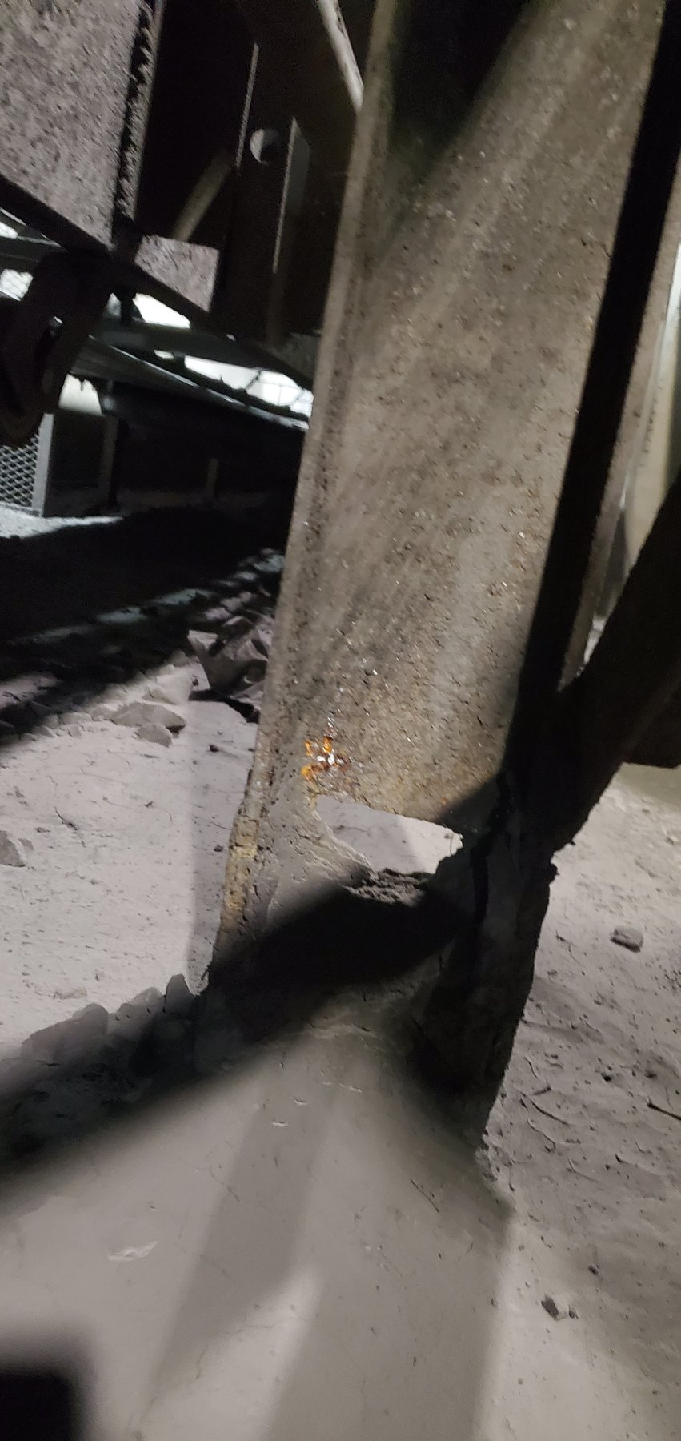  LoadoutStationL1-REF-009 — Steel deterioration and section loss at a separate L1 support location, showing that the condition is not limited to the support illustrated in REF-008.

OBSERVATION | Extensive material/fines accumulation is present around L1, together with concrete deterioration and exposed reinforcement, local steel section loss at more than one support location, and wear consistent with previous/intermittent belt-to-structure contact. In the operating condition observed during the inspection, the belt was running clear of the affected supports and no obvious lateral offset, mistracking or contact was visible.
ENGINEERING ASSESSMENT | The wear slots are consistent with previous or intermittent belt contact, but the available evidence does not establish a continuous present rubbing condition or the mechanical circumstances that produced the wear. The visible concrete and steel deterioration requires structural assessment because remaining capacity cannot be determined photographically. Material and moisture accumulation around the structure may contribute to continued exposure and repeated accumulation around the affected interfaces, but the available evidence does not establish these conditions as the cause of every structural defect.
RECOMMENDED NEXT ACTION | Complete a competent structural assessment of the affected concrete and steel supports and implement the resulting approved repair, strengthening or replacement requirements. Record the wear/contact geometry and observe representative belt tracking and clearance to determine whether a current mechanical contributor remains present. Where a contributing condition is confirmed, correct it and verify the as-left operating clearance. Recurring material, fines and moisture retention around repaired structural interfaces should also be reduced and the repaired condition monitored.

